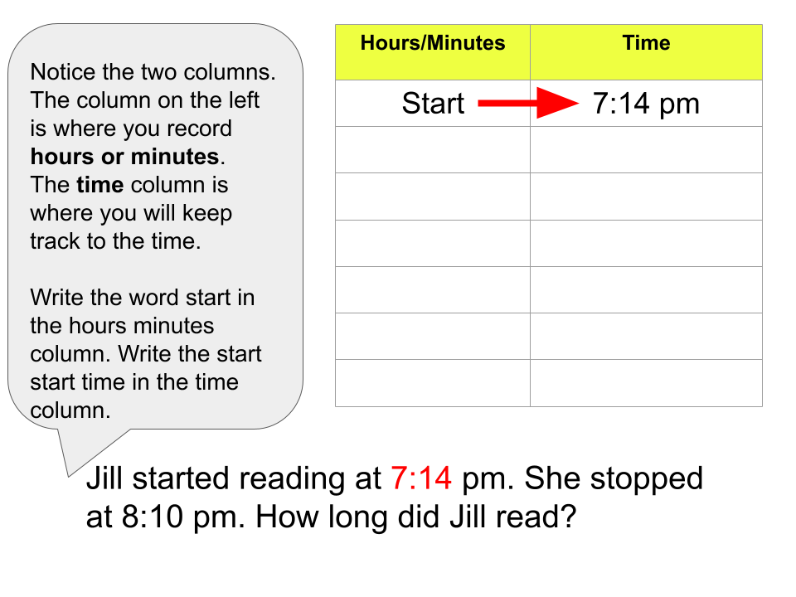

**Hours/Minutes**

**Time**

Start

7:14 pm

Notice the two columns. The column on the left is where you record hours or minutes. The time column is where you will keep track to the time.

Write the word start in the hours minutes column. Write the start time in the time column.

Jill started reading at 7:14 pm. She stopped at 8:10 pm. How long did Jill read?